Project: Virtual Parallels systems

Our students are encouraged to do this project in a team. Each team can have one or two or three members. All team members will need to work together for all the tasks that the project involves such as project planning, creating project specification document, etc. Each project team will turn in one team project report, including all the possible operations descriptions and figures, and each team member must submit the team works to your blackboard submission link.

1. Virtual Parallels systems: Mac OS and Win OS share the hardware.

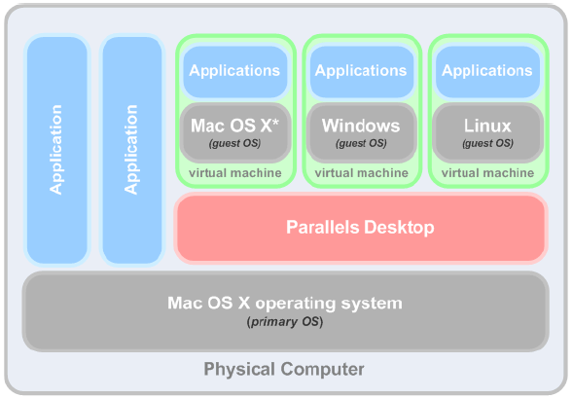   
virtual Box 100/free; win 100; linux 100 ; lastName.txt---- > Xiong.txt;

1. Run mac; --- have all;
2. Run mac + windows; ---- 1.5 Gb/200 win
3. Run mac + Linux; ------ 1.5 Gb/ 100 Gb Lin
4. Run mac + w +L; ------ 1 GB/ 100 Gb for Lin or Win; 2 Gb/300 for Mac

\*Do not use “Format” command to delete this system.

2) The Traditional Model: Mac OS and Win OS don’t share the hardware.

Mac app

Window app

Mac: 4; 500

Window: 4; 500

Physical Hardware: 4 Gb; 500 Gb